**EACH Manifesto**

**Keys for Efficient and Resilient   
Capital Markets**

**December 2024**

**EACH Manifesto – Keys for Efficient and Resilient Capital Markets**

This document describes what CCPs are, the services they provide and the key conditions for European CCPs to continue providing best-in-class risk management, efficiency and transparency to European capital markets.

1. **WHAT ARE CCPs – ORIGINS, NATURE AND IMPORTANCE**

Central counterparties (‘CCPs’) perform independent risk management in financial markets. While CCPs have existed for decades, their importance has been highlighted during the financial crisis (2008-09), COVID-19 and other market stresses, where they acted to limit contagion effect and ensure that despite market stress (e.g. liquidity squeezes, geopolitical events) users continue benefiting from markets that are transparent, stable and fulfil users’ efficiency and risk management demands.

Technically, CCPs act as a buyer to every seller of financial instruments (e.g. stocks, bonds or derivatives) and as seller to every buyer, impartially evaluating the risk exposure of a market participant, requiring appropriate collateralisation and providing anonymity between buyers and sellers. As they interpose themselves in each and every cleared transaction and ensure the collateralisation of exposures, CCPs increase confidence in the market and significantly reduce the cost to the market if a counterparty is unable to fulfil its obligations. CCPs provide safe, transparent, and efficient management of the risks generated by the financial transactions that market participants enter into when seeking to hedge their risks or manage their assets. By centralizing the clearing process, CCPs strengthen market stability and support efficient risk management.

CCPs clear a wide range of financial instruments. However, they can only clear instruments that are standardised and liquid enough so that they can be sold in case of market stresses, as a result of which not all financial instruments are suitable for clearing.

1. **BENEFITS OF CCPs**

CCPs provide benefits to market participants individually and the broader economy in several ways:

|  |  |
| --- | --- |
| CCPs ensure there are resources available to absorb losses that could result from the default of a market participant, limiting any potential contagion to other market participants and the broader economy. This was exemplified by the prevention role played by CCPs in the context of the financial crisis of 2008, which led to the G20 decision to mandate central clearing for standardized OTC derivatives. Recent crises events such as COVID-19 have further demonstrated how CCPs successfully prevented contagion of losses. |   **Reduction of risk** |

|  |  |
| --- | --- |
|   **Efficient use of capital** | CCPs allow market participants to make efficient use of capital through netting of market participants’ positions, thereby reducing counterparty credit risk, liquidity needs and the cost of trading, which also supports capital formation by enabling a stable market environment for the issuance of new financial instruments. CCPs often increase capital and operational efficiency beyond 90%[1]. CCPs also increase settlement efficiency as they can provide securities lending, reduce the number of transactions to be settled thanks to netting, allow for partial deliveries and enforce buy-ins. |

|  |  |
| --- | --- |
| CCPs’ independent risk management play a crucial role in increasing market transparency through:   * Acting as a trusted, central and known counterparty to all market participants * Providing higher transparency of cost of clearing compared to uncleared markets * Valuing market participants’ asset and positions in a fair manner * Proactively developing the CCP risk management approach as markets evolve * Providing independent and predictable risk management to all market participants by applying and making available the risk management methodologies of CCPs |   **Transparency** |

1. **HOW MANY CCPS ARE THERE IN EUROPE AND WHAT DO THEY CLEAR?**

There are 14 CCPs in the EU, 3 in the UK, 1 in Switzerland and 1 in Turkey, managing risks for clearing members and clients with resources beyond +EUR500bn[2]. Generally, CCPs tend to be active beyond their own jurisdiction. There are more than 80 CCPs around the world.

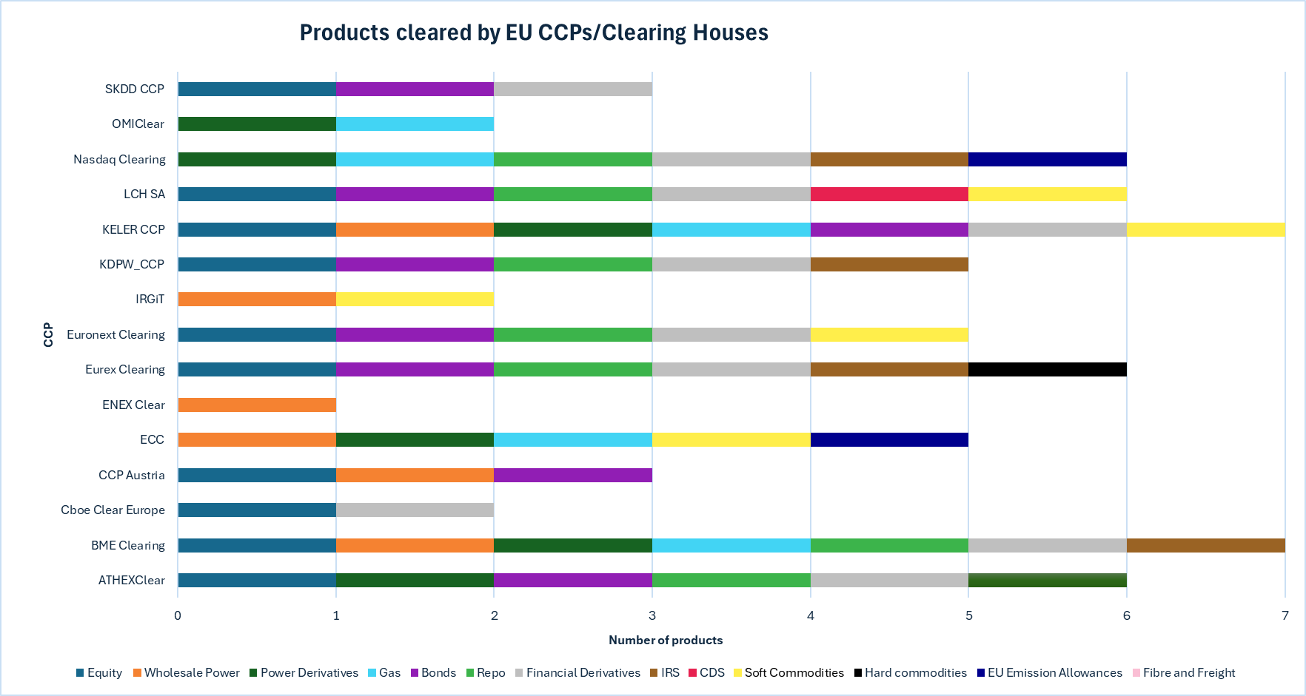

The above chart illustrates the range of products cleared by CCPs[3] in Europe. This broad coverage helps CCPs manage risks across different markets used by participants, ensuring that financial transactions remain safe and transparent.

1. **KEYS FOR EFFICIENT RESILIENCE**

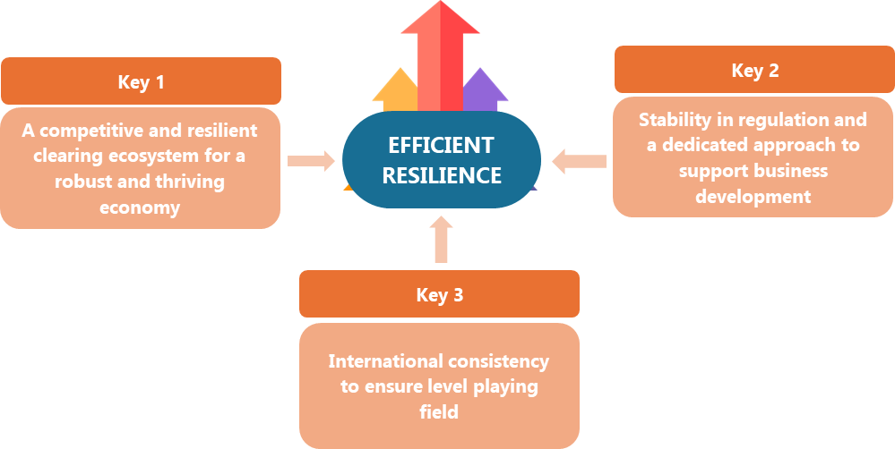

**EFFICIENT RESILIENCE KEY #1 – A COMPETITIVE AND RESILIENT   
CLEARING ECOSYSTEM FOR A ROBUST AND THRIVING ECONOMY**

To reach the goal of a more competitive and resilient clearing ecosystem, we call for:

|  |  |
| --- | --- |
| **Access to central bank facilities** | |
| **Harmonised and straightforward CCP access to central bank facilities** | A harmonised and straightforward framework of access to central bank facilities would allow the CCP clearing ecosystem to more broadly use central bank deposit and liquidity facilities, the latter especially in the case of extreme market conditions. This would limit exposure to settlement risk and insolvency risk of commercial banks, strengthen CCPs' risk management practices, allow for better management of investment risk, and promote a global level-playing field for CCPs. |

|  |  |
| --- | --- |
| **Efficient capital markets** | |
| **Removal of red tape for efficient capital markets** | EACH supports the removal of red tape where possible to facilitate efficient capital markets, including harmonizing tax-related rules such as withholding and transaction taxes, supporting demand for capital market products, establishing savings products and addressing the reality of an ageing population and increasingly smaller public pensions funds. |

|  |  |
| --- | --- |
| **Procedures for the approval of new products and services and changes to risk models** | |
| **Effective implementation of the new approval procedures** | EACH supports promoting the competitiveness of European CCPs through an effective implementation of the revised process for approval of new products and changes to risk models pursuant to EMIR 3 (i.e. adhering to the approval timelines in EMIR 3). |

|  |  |
| --- | --- |
| **Avoid duplicative or confusing requirements  by considering CCP-specificities** | |
| **Consideration of the specificities of CCP services** | EACH supports smart rule-making processes that promote clear and non-repetitive provisions, especially when they are part of different pieces of legislations, some especially designed for CCPs and some more general. The example of different pieces of EU legislation related to operational resilience without much apparent coordination among them has led to unnecessary legal and implementation costs for the industry. EACH encourages an approachwhich considers the specificities of the services provided by CCPs as well as already existing legislations. |

|  |  |
| --- | --- |
| **A transparency framework for all actors involved** | |
| **Implementation of the enhanced EMIR transparency rules** | It is crucial to ensure that *all* the players involved in the clearing ecosystem – CCPs, clearing members, direct and indirect clients, authorities – contribute to and benefit from an effective transparency framework. EACH therefore supports the implementation of the enhanced EMIR transparency rules and the EU and international work done around margin transparency and liquidity preparedness, which goes beyond CCPs. |

|  |  |
| --- | --- |
| **Transition to adequate settlement cycles** | |
| **Efficient transition** | EACH calls for an efficient transition towards T+1, with the legal certainty provided by public authorities. |

|  |  |
| --- | --- |
| **Anti-procyclicality (APC) measures** | |
| **Focus on an outcome-based approach** | The future work on APC should move away from prescriptive measures, and towards a more outcome-based approach, creating a more leveled playing-field at global level. EACH also supports the requirement for ESMA to draft a quantitative definition of APC. Any regional work on APC should also align with and avoid front-running the ongoing work at international level. |

|  |  |
| --- | --- |
| **Liquidity management by non-bank market participants (NBFI)** | |
| **Enhancement of the liquidity preparedness of NBFIs for margin and collateral calls** | All NBFIs taking part in clearing should be as well-equipped as possible to manage liquidity demands during market stress, as outlined by the FSB recommendations[4]. This includes facilitating the uptake of alternative clearing access models and implementing efficiently, also for non-financial clearing members and non-financial clients, the EMIR 3 framework allowing for the possibility of posting non-cash collateral (e.g. bank guarantees) that meet the required standards. |

|  |  |
| --- | --- |
| **Uncleared bilateral market** | |
| **Encourage clearing whenever possible** | EACH supports the implementation of an approach that encourages clearing whenever possible and calls for those asset classes that are currently part of the uncleared sphere of the market (a practice known in some parts of the value chain as “internalisation”) to be cleared, provided that they are suitable for central clearing. |

**EFFICIENT RESILENCE KEY #2 – STABILITY IN REGULATION AND A DEDICATED APPROACH TO SUPPORT BUSINESS DEVELOPMENT**

|  |  |
| --- | --- |
|  | Over the last 15 years the European clearing sector has been strictly regulated by several pieces of legislations and international standards. |
| **CCPs comply with strict regional and international legislations** | European CCPs have one of the most stringent regulatory frameworks, currently being strictly regulated via the [European Market Infrastructure Regulation](https://eur-lex.europa.eu/legal-content/EN/TXT/PDF/?uri=CELEX:32012R0648) (EMIR), the UK EMIR, as well the as the [CCP Recovery and Resolution Regulation](https://eur-lex.europa.eu/legal-content/EN/TXT/PDF/?uri=CELEX:32021R0023) (CCP RR), the UK CCP RR and similar legislations in Switzerland and Turkey. Such regulations seek to ensure the robust functioning of CCP risk management, set out the relevant supervisory framework(s) as well as define the necessary steps to be followed and the tools to be utilised in the unlikely event of a CCP default. Hence, they not only set a global benchmark but have also proven in recent crisis events to have made the European financial systems stable and robust. In addition, as highly regulated entities, CCPs have acquired in-depth experience and practice in developing and applying risk management requirements, including the management of operational and ICT risks. CCPs therefore commit to ensure robust operational resilience, an aspect that has received increasing attention from regulators and has been reflected in legislations such as the Digital Operational Resilience Act (DORA). Finally, in addition to being subject to the European legislation, European CCPs also adhere to international standards for CCPs such as the [Principles for financial market infrastructures](https://www.bis.org/cpmi/publ/d101.htm) (PFMI), developed by international bodies such as CPMI, IOSCO and FSB, the FSB [Key Attributes of Effective Resolution Regimes](https://www.fsb.org/wp-content/uploads/r_141015.pdf), as well as any other global guidance that the international standard setting bodies regularly issue. |

|  |
| --- |
| **Regulation should be proportionate, stable and fit-for-purpose** |
| Given the robust legislative framework of CCPs, we call for **regulation to be** **proportionate, stable and fit-for-purpose.** We strongly advocate avoiding unnecessary changes and excessively detailed granular provisions that could hinder CCPs’ risk management responses to market stresses and undermine the supervisory framework, making it excessively complex and inefficient and therefore preventing the growth opportunities that CCPs bring to companies and investors. Furthermore, any eventual pieces of legislations should be tailored to the specific nature of CCPs as risk managers and be shaped accordingly, in order to achieve the desired effects. |

**EFFICIENT RESILIENCE KEY #3 – INTERNATIONAL CONSISTENCY TO ENSURE LEVEL PLAYING FIELD**

|  |
| --- |
| **Europe has set high standards compared to international work** |
| Europe has in some cases been at the forefront of several regulatory-related initiatives, setting important standards of quality and efficiency. For instance, the recent provisions on transparency defined in the EMIR 3 legislation seek to ensure an efficient disclosure framework from all the actors involved in the clearing industry. At the same time other jurisdictions lag behind in the implementation of global standards. This mismatch means that European CCPs and non-European CCPs are subject to different standards and regulatory requirements. It is important to **ensure consistency at global level to achieve a level playing field with other jurisdictions, without however undermining European standards**. |

**About EACH**

The European Association of CCP Clearing Houses (EACH) represents the interests of Central Counterparties (CCPs) in Europe since 1992. CCPs are financial market infrastructures that significantly contribute to safer, more efficient and transparent global financial markets. EACH currently has 18 members from 14 different European countries. EACH is registered in the European Union Transparency Register with number 36897011311-96.

1. Source: Estimate based on data provided by EACH Members
2. Source: Calculation based on Q4 2023 [Public Quantitative Disclosures](https://eachccp.eu/cpmi-iosco-public-quantitative-disclosure/)
3. ENEX Clear and IRGiT included in the graph as clearing houses.
4. <https://www.fsb.org/wp-content/uploads/P170424.pdf>